**Concepts of Containerization**

Table of Contents

**Introduction:** 3

**Containerization:** 3

**Key Concepts of Containerization:** 3

The key concepts of containerization include: 4

**How Docker Simplifies Containerization:** 4

Docker simplifies containerization in the following ways: 4

**Findings and Recommendations:** 4

To address these challenges, developers should: 5

**Conclusion:** 5

**Questions for discussion in the workshop session:** 5

**References:** 6

# **Introduction:**

Docker has become one of the most popular containerization platforms for developers since its release in 2013. The platform allows developers to build, deploy, and run applications in a portable and efficient manner, reducing the need for hardware resources and increasing the scalability and flexibility of the development process. Docker is a tool designed to create, deploy, and run applications by using containers, which are isolated environments that encapsulate all the dependencies and configurations required to run an application.

In this report, we will discuss why Docker has become popular with developers and how it has simplified an old way of working. Docker allows developers to package their applications into containers, which can be easily moved between different environments, such as development, staging, and production, without the need to change any code. This simplifies the deployment process and eliminates many of the problems associated with traditional software deployment methods, such as version conflicts, configuration issues, and compatibility problems.

The report will first provide an overview of the Docker platform, its key features, and its benefits for developers. We will then discuss the issues and concepts that are relevant to the topic, including containerization, virtualization, and cloud computing. Finally, we shall provide a summary of the conclusions as well as suggestions made by the report with reference to the topics covered.

# **Containerization:**

A containerization is an approach to software development that allows applications to be packaged with their dependencies and run consistently across different computing environments. Containerization has gained significant popularity in recent years due to its ability to solve the challenges posed by traditional software development practices, such as the need to run applications on different operating systems or manage dependencies. One of the most popular containerization platforms is Docker, which has revolutionized the way developers build and deploy software applications.

In this report, we will explore the key concepts of containerization and how Docker has simplified the process. We will discuss the traditional way of working with software applications and how Docker has made it easier for developers to work with containers. We will also examine the key features of Docker that have made it a popular choice among developers, such as its ability to manage dependencies and provide a consistent runtime environment.

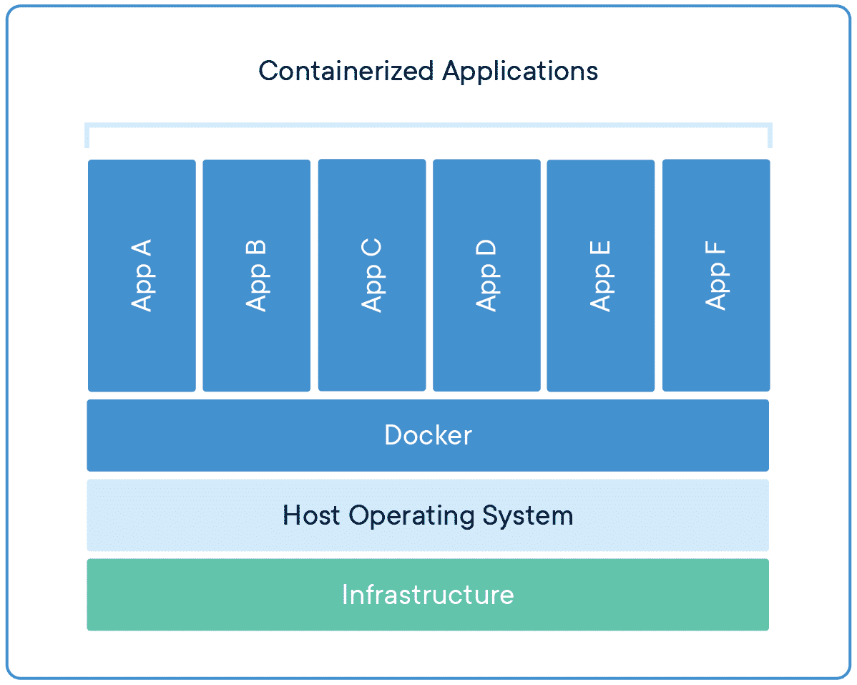

Furthermore, we will examine how Docker simplifies the deployment of applications across different environments, including cloud infrastructure and local machines. Finally, we will summarize our findings and recommendations on how organizations can benefit from using Docker as a containerization platform to streamline their software development and deployment processes.

## **Key Concepts of Containerization:**

Containerization is a method of packaging and deploying software applications in a self-contained, isolated environment. Containers allow developers to package an application along with all its dependencies and run it consistently across different environments. Containers are lightweight and efficient, allowing developers to create and deploy applications faster than traditional virtual machines.

### The key concepts of containerization include:

1. Container image: An app's code, runtime, system tools, libraries, as well as settings are all included in a container image, which is a small, standalone, executable package.
2. Container runtime: A container runtime is a tool that is used to create, start, stop, and manage containers. The container runtime provides the necessary isolation and security for containers.
3. Container orchestration: Automating the deploying, scaling, as well as maintenance of containerized applications is known as container orchestration. Kubernetes, as well as Docker Swarm, are two examples of container lifecycle management systems.

## **How Docker Simplifies Containerization:**

Docker has simplified containerization by providing an easy-to-use platform that allows developers to package and deploy applications in containers. Docker provides a Docker file, which is a script that defines the configuration of a container image. Developers can use the Docker file to specify the dependencies, libraries, and configurations required for the application to run. Docker also provides a registry for storing and sharing container images, making it easy for developers to share and deploy containerized applications.

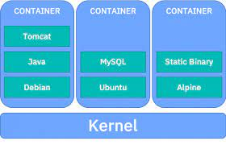

### Docker simplifies containerization in the following ways:

1. Ease of use: Docker provides a simple and easy-to-use interface for creating and managing containers. Developers can use Docker commands to create, run, and manage containers without having to worry about the underlying infrastructure.
2. Portability: Docker containers are portable across different environments, making it easy for developers to deploy applications in different environments.
3. Efficiency: Docker containers are lightweight and efficient, allowing developers to create and deploy applications faster than traditional virtual machines.

## **Findings and Recommendations:**

Docker has become popular with developers because it simplifies containerization, making it easier to package, deploy, and manage applications in containers. Developers can create container images using a Docker file, store them in a registry, and deploy them consistently across different environments. Docker has also made it possible for developers to run multiple applications on a single host without worrying about dependencies and conflicts.

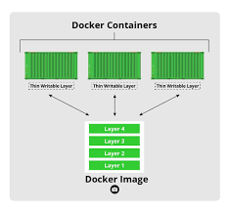

However, there are some challenges associated with using Docker. Managing the lifecycle of containers can be complex, and container orchestration tools such as Kubernetes and Docker Swarm can be difficult to set up and maintain. Developers also need to ensure that containerized applications are secure and compliant with industry standards.

### To address these challenges, developers should:

1. Invest in container orchestration tools: Container orchestration tools such as Kubernetes and Docker Swarm can help manage the lifecycle of containers and ensure that applications are running smoothly.
2. Pay attention to security: Developers should ensure that containerized applications are secure and comply with industry standards. This includes using secure container images, implementing access controls, and regularly updating containers.
3. Follow best practices: Developers should follow best practices when creating and managing containers. This includes using small and efficient container images, minimizing the attack surface, and separating data and configuration from the application code.

# **Conclusion:**

In conclusion, Docker has become a popular containerization platform for developers due to its ease of use, portability, and efficiency. Docker has simplified the process of containerization, which was an old way of working, by providing a user-friendly interface, easy-to-use CLI commands, and a rich ecosystem of images and tools. Docker also provides a robust orchestration system that simplifies the management and scaling of containers. It has helped developers to overcome the challenges of application portability and deployment by allowing them to build, ship, and run applications in any environment, from local development to cloud-based production environments.

However, it is important to note that Docker is not a perfect solution and has its limitations, such as security concerns and potential performance issues. Developers need to consider these factors when using Docker and make sure to follow best practices and guidelines to ensure the security and efficiency of their containerized applications.

## **Questions for discussion in the workshop session:**

1. What are the benefits of containerization, and how does Docker simplify the process?
2. How does Docker differ from traditional virtualization technologies?
3. What are the potential security concerns when using Docker, and how can they be addressed?
4. How can Docker be used to improve the development and deployment process of applications?
5. What are the limitations of Docker, and how can they be mitigated?

# **References:**

* Docker Documentation. (2021). Retrieved from <https://docs.docker.com/>
* Foskett, S. (2018). What is Docker, and why is it so darn popular? Retrieved from <https://thenewstack.io/what-is-docker-and-why-is-it-so-darn-popular/>
* Gupta, A. (2020). Docker: A Comprehensive Guide. Apress.
* Ranganathan, A., & Ezhilchelvan, P. (2018). Containerization: A new era of deployment in the cloud. IEEE Cloud Computing, 5(1), 68-75.
* Vaishnav, S., & Jagtap, V. (2021). Containerization and Container Orchestration: A Review and Comparative Study of Docker, Kubernetes, and OpenShift. International Journal of Advanced Science and Technology, 30(1), 1941-1952.